**CI/CD Pipeline [ Jenkins on EC 2 ]**

**Install Jenkins on EC2 Server**

1. **Installing Jenkins**

<https://www.jenkins.io/doc/tutorials/tutorial-for-installing-jenkins-on-AWS>

1. **Installing Maven**

sudo yum update

sudo -i

mkdir /opt/maven

cd /opt/maven

wget https://dlcdn.apache.org/maven/maven-3/3.8.6/binaries/apache-maven-3.8.6-bin.tar.gz

tar -xvzf apache-maven-3.8.6-bin-tar.gz

cd root

ls -la [ check for .bash_profile file ]

vi .bash_profile

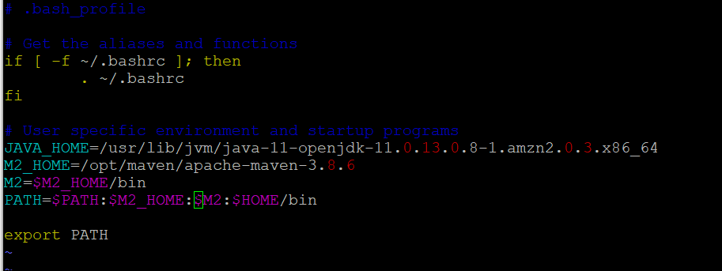

* Press ESC and then type :wq and hit enter to save changes

1. **Installing Git**

sudo -i

yum install git -y

Go to Jenkins - Installed following plug-in

1. Maven Invoker
2. Maven Integration
3. Pipeline Maven Integration
4. GitHub

Go to Dashboard – Manage Jenkins – Global Tool Configuration

Add JDK

/usr/lib/jvm/java-11-openjdk-11.0.13.0.8-1.amzn2.0.3.x86_64

Add Maven

/opt/maven/apache-maven-3.8.6